**Assignment 2**

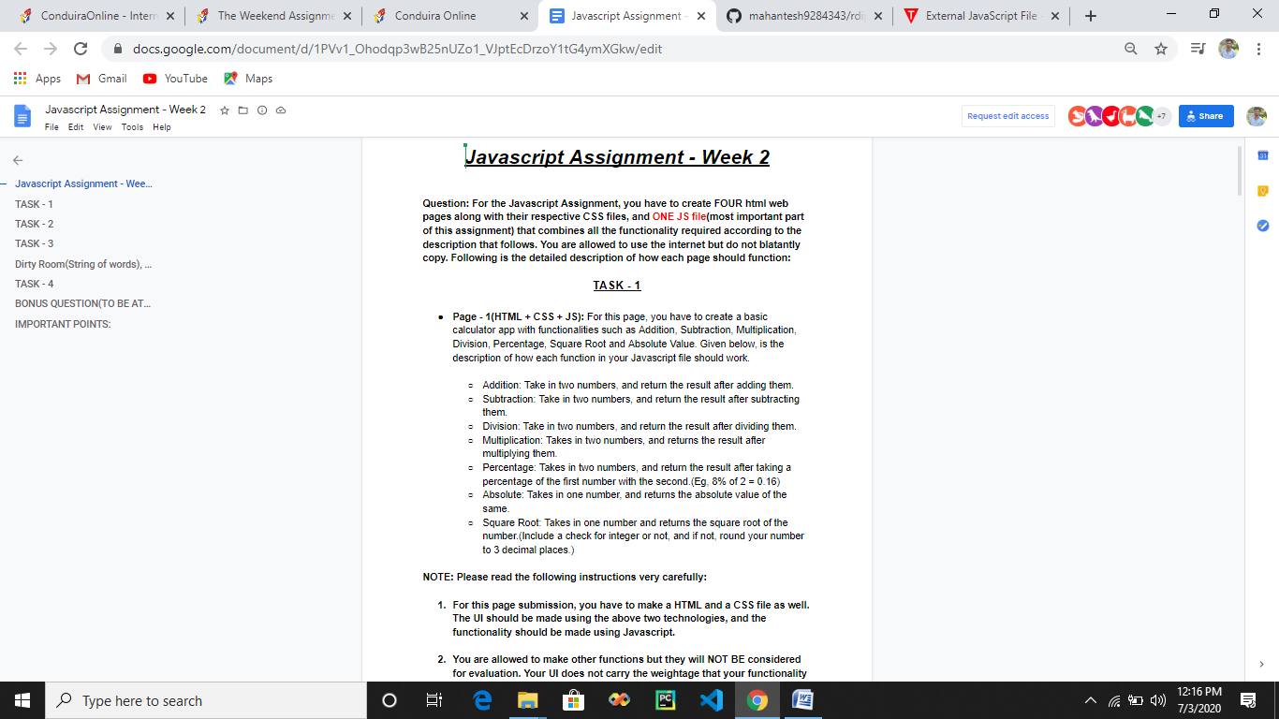

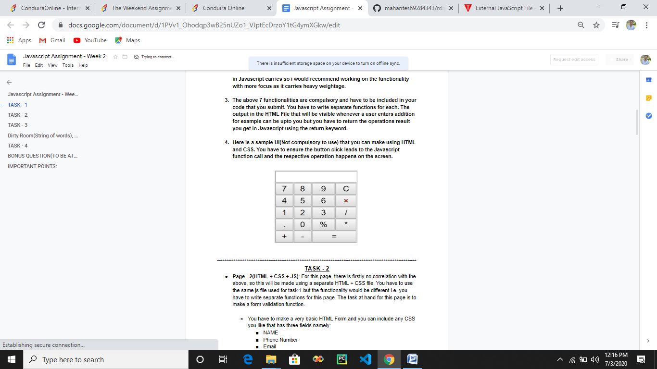

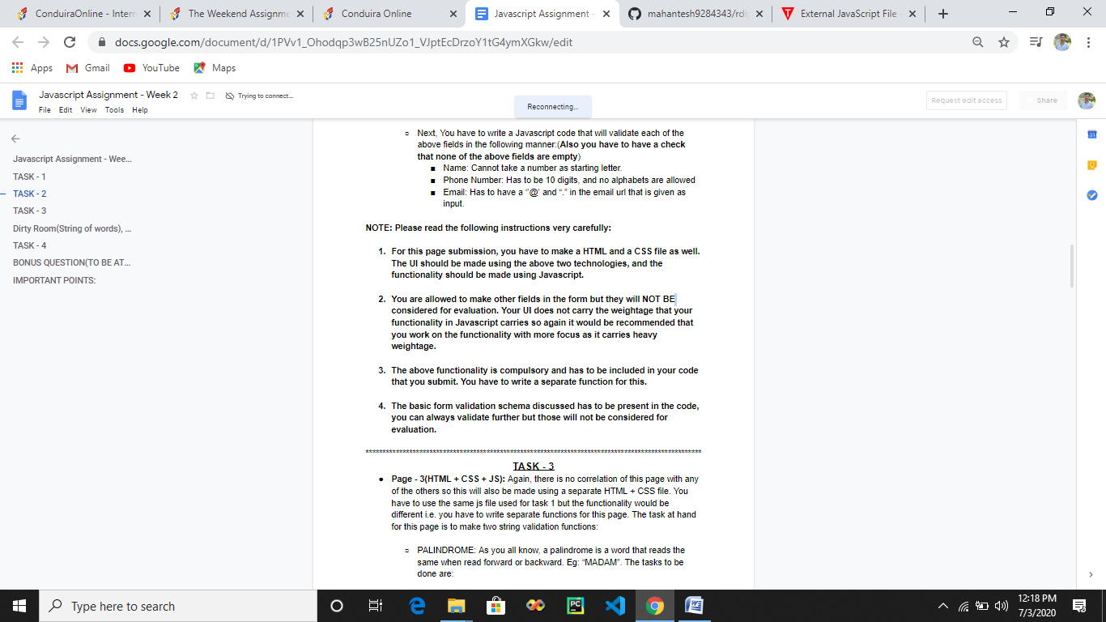

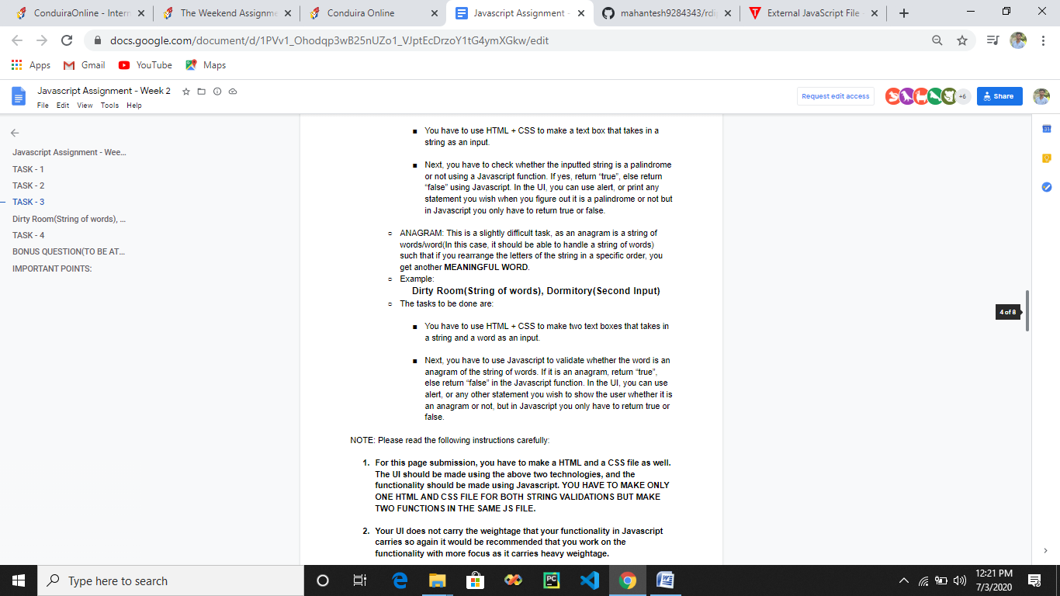

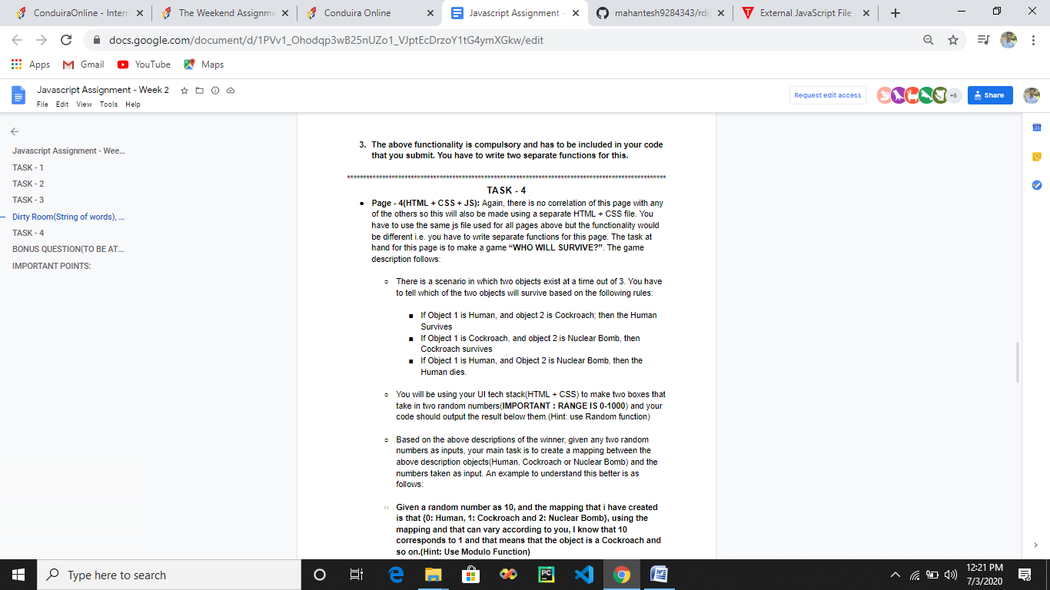

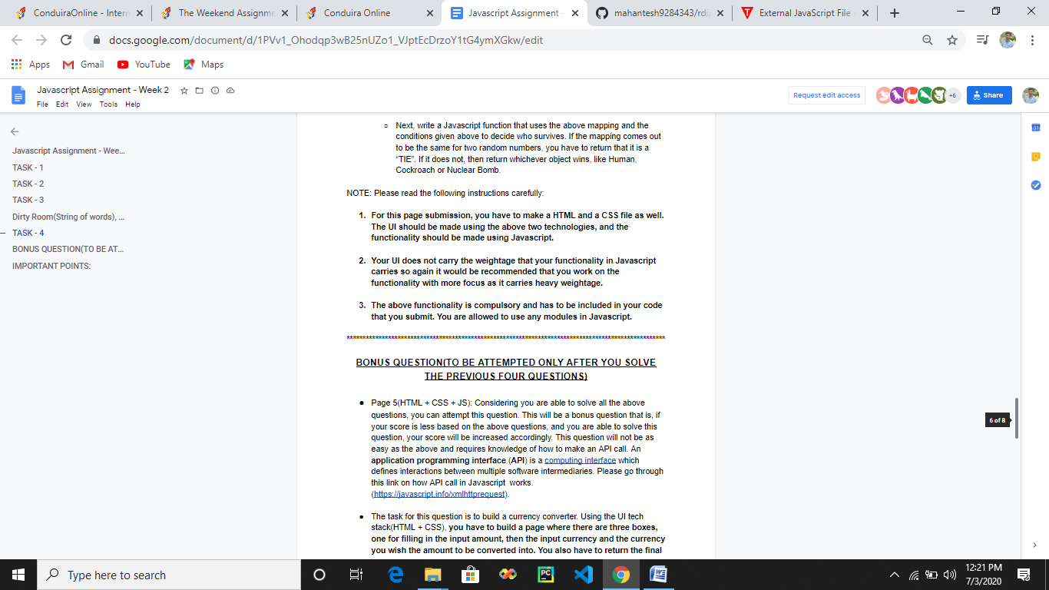

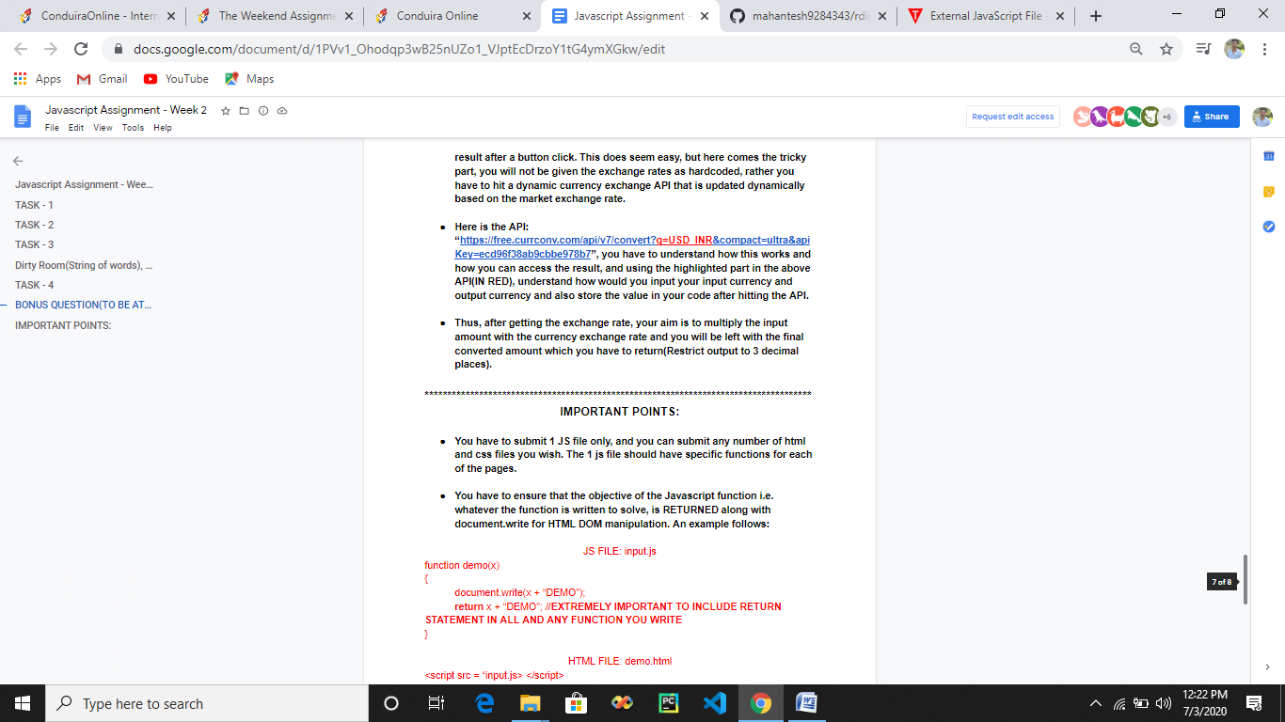

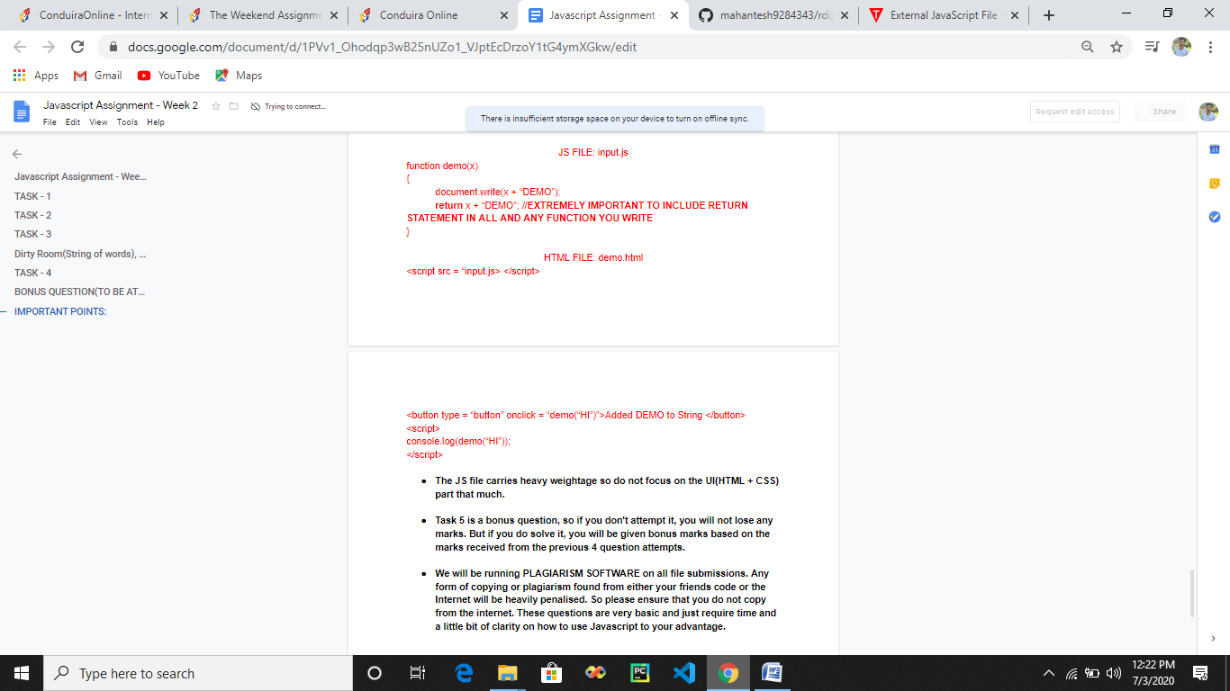

**Explanation of the Assignment**

**Task 1 :-**

* **4 tasks so 4 HTML, 4 CSS and 1 JS file (Which include all JS of 4 tasks).**
* **JS contains lot of weight age so give more importance to JS.**
* **Every function should contain return type (if return type not there then 0 marks will be allotted for that part).**
* **Bootstrap is allowed to use.**
* **In square root operation we have to check if number is decimal number , if not then round it to 3 decimal number**
* **In calculator task not necessary to make similar to calculator but take input and have buttons to perform + , - , * …….**
* **We can use text box to take input and perform operation..**
* 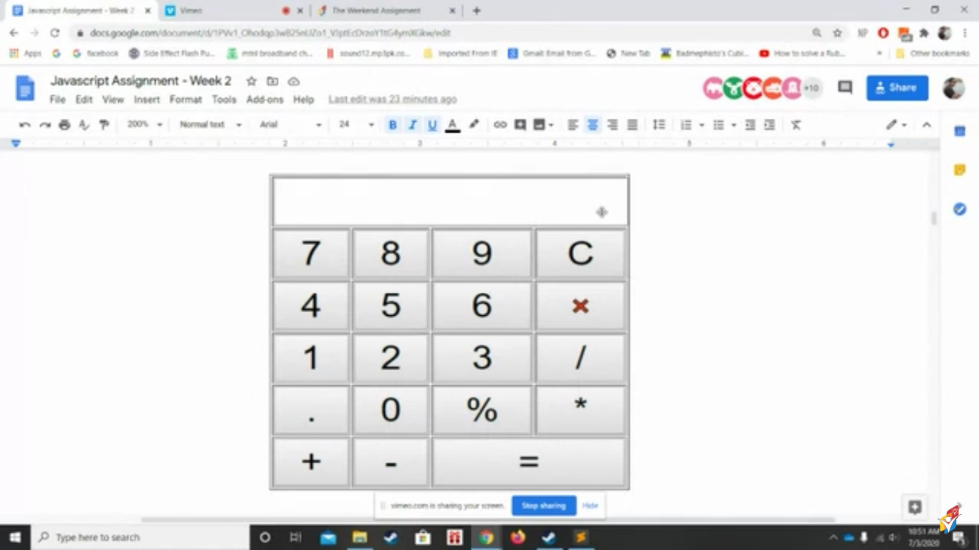
* **Here return statement should return the addition of 2 number as shown in the example at the end if the word file.(use the same logic)**
* **Even if the code is not running in any function but include return statement. Most important.**

**Task 2 :-**

* **Only one JS file for all 4 task and all function should contain return type**
* **Compulsory to make external JS file**
* **External CSS file too(but not compulsory)**

**Task 3 : -**

* **Only one JS file for all 4 task and all function should contain return type**
* **In Palindrome take 1 textbox and in Anagram 2 text box (1 text box will take string of words and other one will take one word to be checked)**

**Anagram is a string of words when we rearrange the letters we get the meaningful word.**

**So create a function to check if the word entered in 2nd text box is an anagram of the string of words entered in 1st text box.**

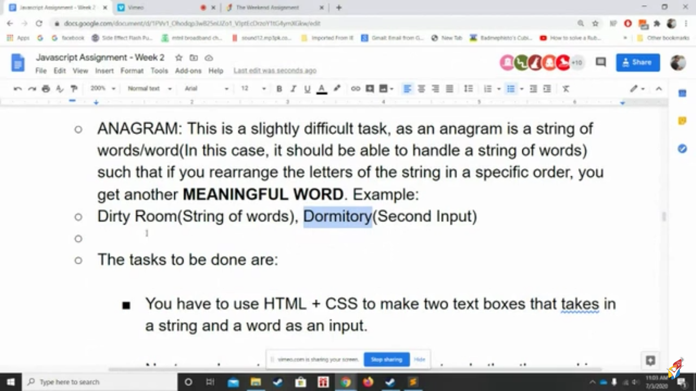

**I will give 1st string of words and 2nd word(2nd input) and after rearranging letter in 1st string of words I have to check if I get 2nd input word or not.**

**Task 4 :-**

* **Use Random function in JS to get the Random number**
* **Main difficult task is to create the mapping in the function.**

**Can Create mapping using module function or using even no ,odd no , zero . [ 0 : Human, odd : Cockroach, even: Nuclear or use module function ]**

**Its similar to stone, paper and scissor**

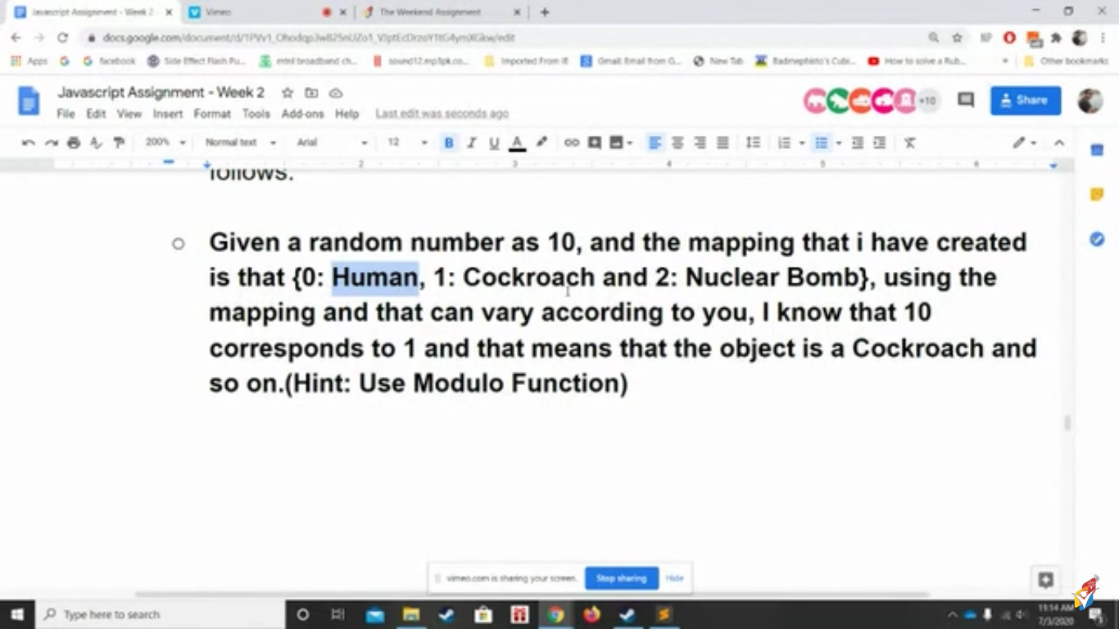

**Return statement is must in all function in Javascript file**

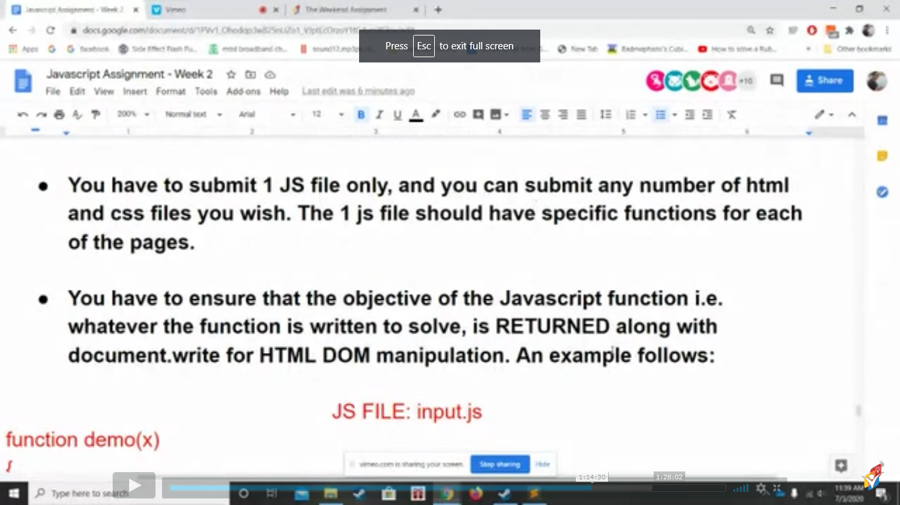

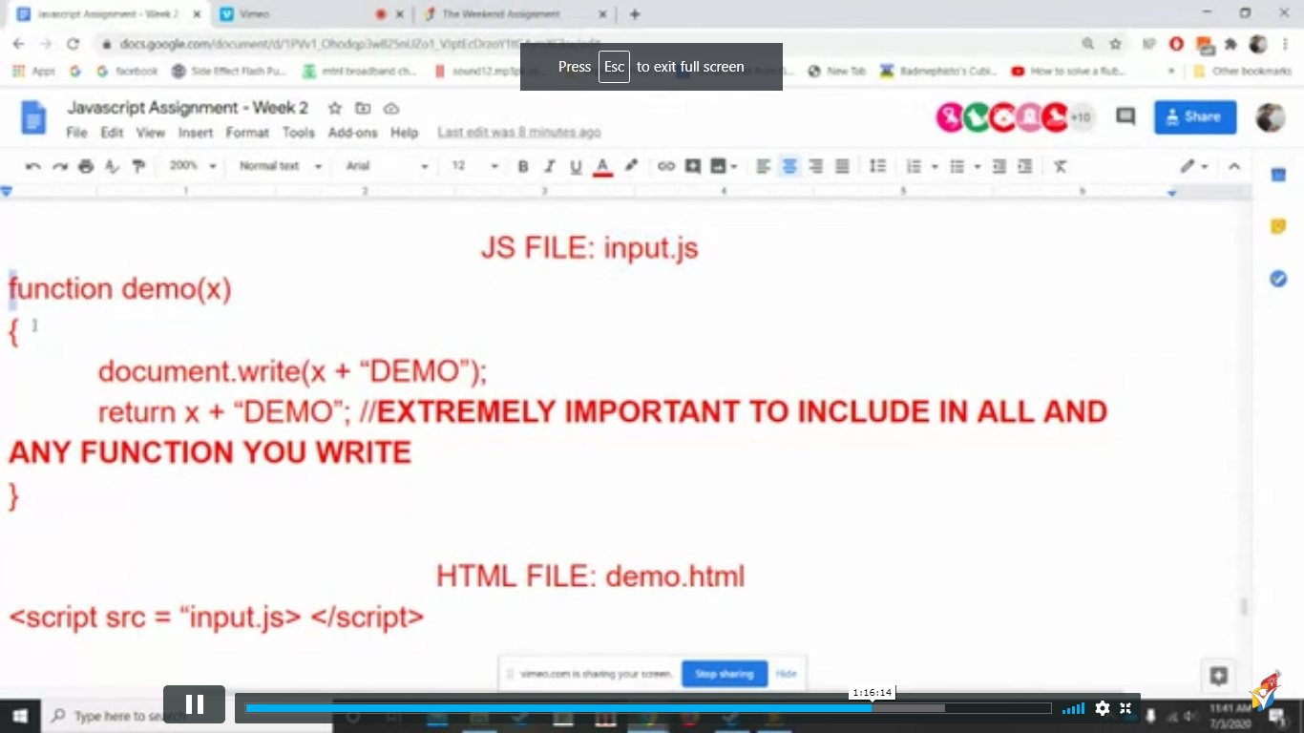

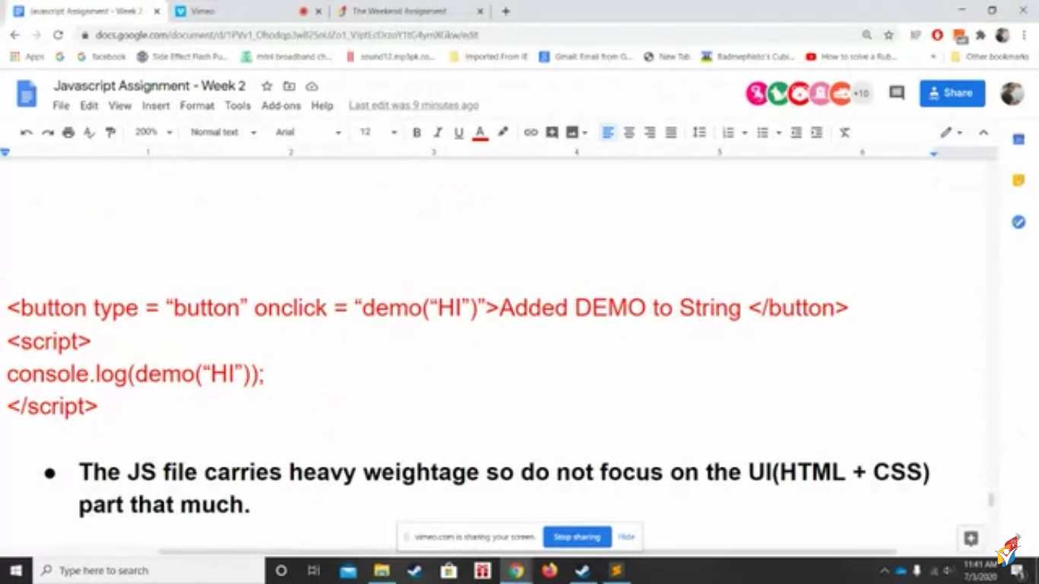

* **On clicking on button demo function will be called which will add Hi and DEMO and document. Write will display result on the page but it is compulsory to use return the result and check in console if your getting the result in console.**
* **When we use return and console statement we get to see the result in console whatever is returned.**